**Aim: To understand and implement Computer vision for skin tumor image evaluation using morphological operators and their applications in MATLAB.**

**Matlab Code:**

clc;

close all;

clear all;

% Read the test Image

% Convert the image to binary image

myorigimg = imread(' skintumor.jpe');

myorigimg = im2bw(rgb2gray(myorigimg));

subplot(3, 3, 1);

imshow(myorigimg);title('Originalimage');

% Create Structuring Element

se = strel('disk', 9);

% Perform dilation operation using imdilate command

% Display the dilated image

mydilatedimg = imdilate(myorigimg, se);

subplot(3, 3, 2);

imshow(mydilatedimg);title('Dilated image');

% Perform Erosion operation using imerode command

% Display the Eroded image

myerodedimg = imerode(myorigimg, se);

subplot(3, 3, 3);

imshow(myerodedimg);title('Eroded image');

% Find Internal Boundary

% Internal Boundary = Dilated Image AND Not of Eroded Image

% Display Internal Boundary

internalboundimg = mydilatedimg& ~ myerodedimg;

subplot(3, 3, 4);

imshow(internalboundimg,[]);title('Internal Boundary');

% Find External Boundary

% External Boundary = Dilated Image AND Not of Eroded Image

% Display External Boundary

externalboundimg = mydilatedimg& ~myorigimg;

subplot(3, 3, 5);

imshow(externalboundimg,[]);title('External Boundary');

% Find Morphological Gradient

% Morphological Gradient = Dilated Image AND Not of Eroded Image

% Display External Boundary

mymorphgradimg = imsubtract(myorigimg,myerodedimg);

subplot(3, 3, 6);

imshow(mymorphgradimg,[]);title('Morphological Gradient');

% Perform Thinning operation using bwmorph() command

% Display the dilated image

thinf = bwmorph(myorigimg,'thin');

subplot(3,3,7);

imshow(thinf);title('Thinning of the Image');

% Perform Thickening operation using bwmorph()command

% Display the dilated image

thickf = bwmorph(myorigimg,'thicken');

subplot(3,3,8);

imshow(thickf);title('Thickening of the Image');

% Perform Skeletonozation operation using bwmorph()command

% with 8 iterations and display the dilated image

skelf100 = bwmorph(myorigimg,'skel',9);

subplot(3,3,9);

imshow(skelf100);title('Skeletonization - 9 iterations');

**Results:**

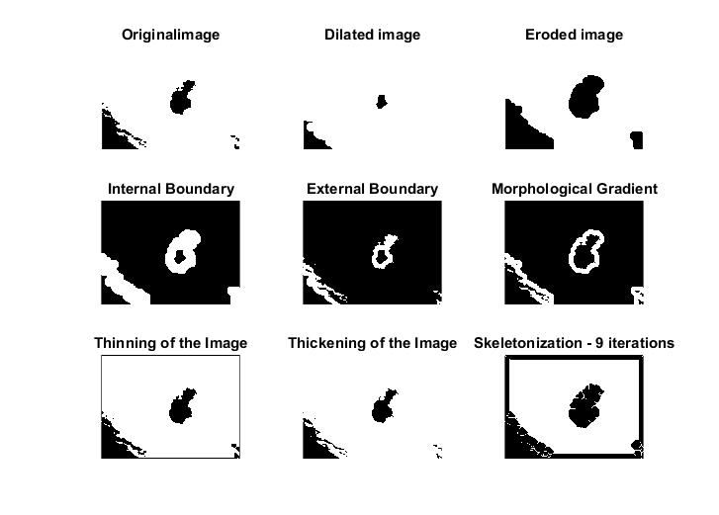

**Conclusion:** Thus we have concluded from this experiment that it can be observed that external boundaries are larger than the internal boundaries and morphological gradient is thicker.